**Filters in Servo Drive Systems**

In general servo system tuning approach, there are two main filter type for operations such as band pass filter for detecting the disturbance signal and band stop (band reject) for eliminating the detected disturbance. There are three critical parameter for filter as BW, Q factor,

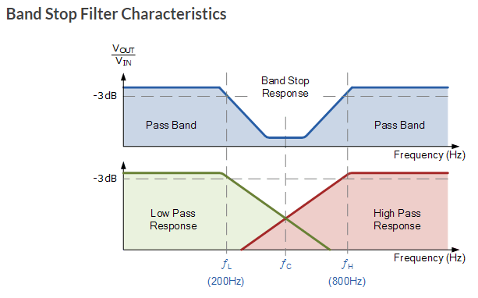

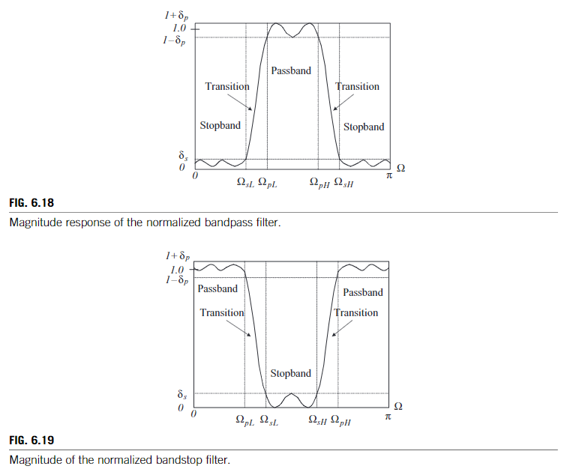

One of the important issue is embedding the filtering to the control block digitally. For this purpose there are three main approaches such as direct discrete, cascade or parallel form.

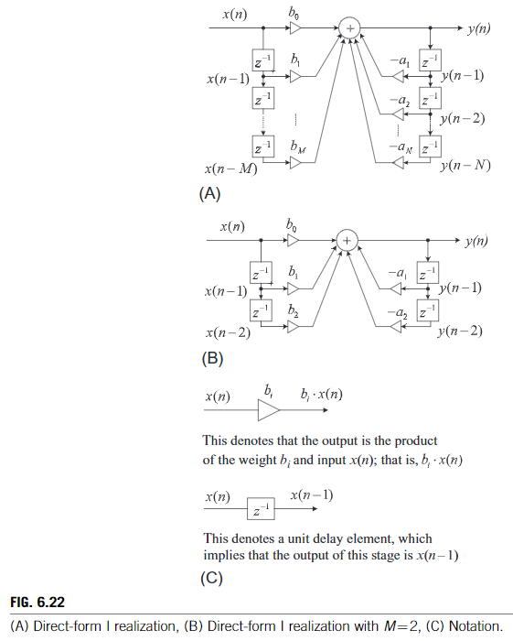 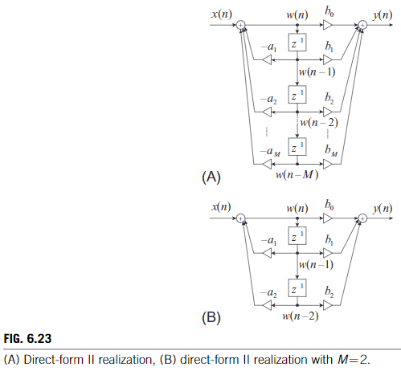

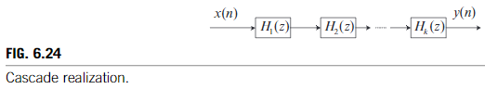 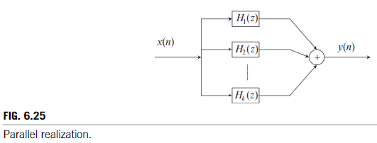

**NOTCH**

A notch filter is a bandreject filter with a very narrow bandwidth.



**BIQUAD**



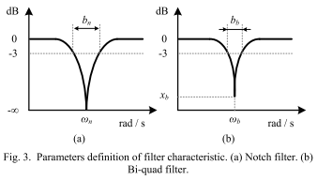

**The Twin-T notch (band-stop) filter**



[DIGITAL SIGNAL PROCESSINGSYSTEMS, BASIC FILTERINGTYPES, AND DIGITAL FILTERREALIZATIONS-ch6]

[A Modified Full-Band Adjustable Bi-Quad Filter for Mechanical Resonance Suppression in Industrial Servo Drive Systems]

<http://sim.okawa-denshi.jp/en/TwinTCRtool.php>